Kubernetes Task 8

- Create and Test a Kubernetes Pod with an EmptyDir Volume
- Configure a HostPath Volume in Kubernetes and Validate Data Persistence
- Deploy an Amazon EBS Volume Using Persistent Volume and Persistent Volume Claim (PVC)
- Set Up an Amazon EFS Volume and Attach it to Multiple Pods
- Implement and Test Liveness and Readiness Probes in a Kubernetes Pod

Step 1 — Create the YAML
- Run
vi emptydir-pod.yaml
- Paste

- apiVersion: v1
- kind: Pod
- metadata:
- name: emptydir-pod
- spec:
- containers:
- - name: writer
- image: busybox
- command:
- - sh
- - -c
- - |
- echo "Hello from EmptyDir volume" > /data/message.txt
- sleep 3600
- volumeMounts:
- - name: shared-data
- mountPath: /data

- - name: reader
- image: busybox
- command:
- - sh
- - -c
- - |
- sleep 5
- cat /data/message.txt
- sleep 3600
- volumeMounts:
- - name: shared-data
- mountPath: /data

- volumes:
- - name: shared-data
- emptyDir: {}

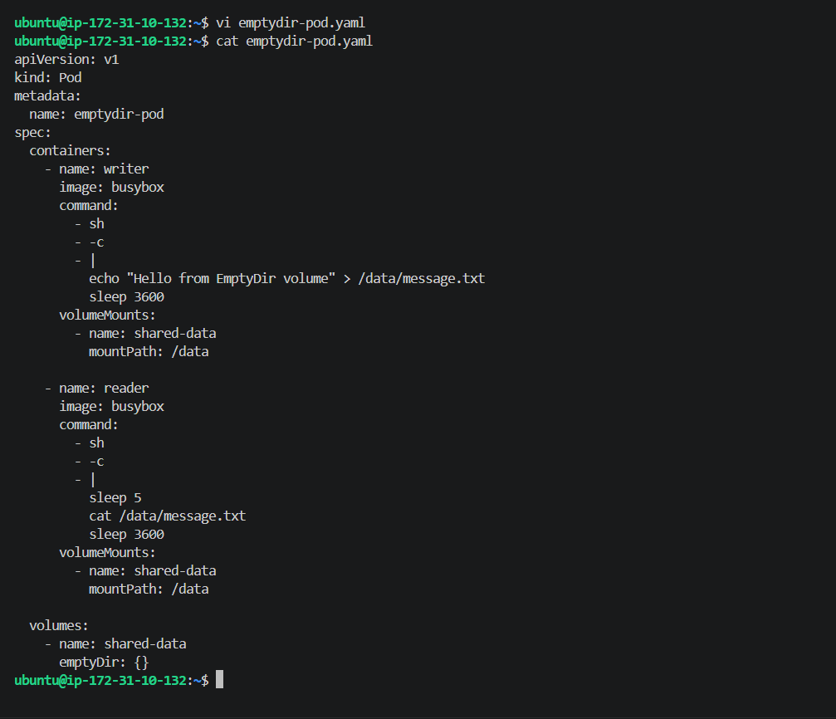
Step 2 — Apply it
kubectl apply -f emptydir-pod.yaml
Expected:
pod/emptydir-pod created
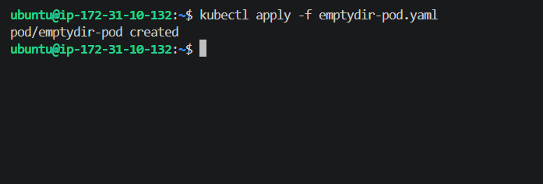

EmptyDir Pod has been created successfully.
Now let's verify that both containers are running.
Run:
kubectl get pod emptydir-pod
Expected:
NAME READY STATUS RESTARTS AGE
emptydir-pod 2/2 Running 0 ...
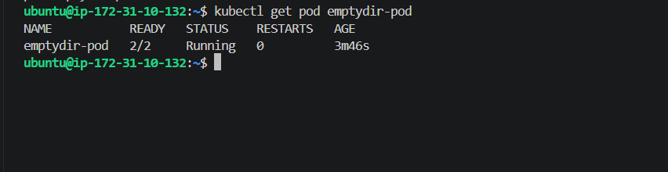
Step 3 — Verify the shared EmptyDir data
Now let's check the file from the reader container.
Run:
kubectl exec emptydir-pod -c reader -- cat /data/message.txt
Expected:
Hello from EmptyDir volume
Step 1 — We'll use a temporary privileged Pod
First, create this file on your control-plane:
vi hostpath-setup.yaml
Paste:
apiVersion: v1
kind: Pod
metadata:
name: hostpath-setup
spec:
nodeName: ip-172-31-10-231
containers:
- name: setup
image: busybox
command:
- sh
- -c
- |
mkdir -p /host-data
echo "Hello from HostPath volume" > /host-data/message.txt
cat /host-data/message.txt
sleep 3600
volumeMounts:
- name: host-storage
mountPath: /host-data
volumes:
- name: host-storage
hostPath:
path: /data/hostpath
type: DirectoryOrCreate
Step 2 — Apply it
kubectl apply -f hostpath-setup.yaml
Then:
kubectl get pod hostpath-setup -o wide
We want:
hostpath-setup 1/1 Running ... ip-172-31-10-231
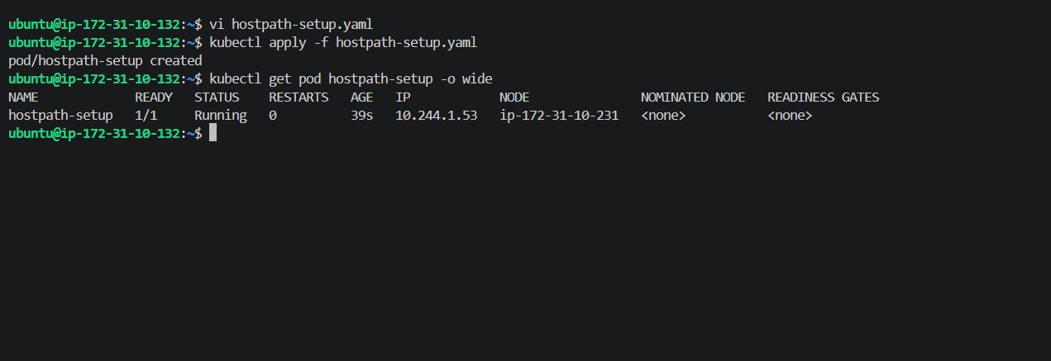
Step 3 — Read the file from the Pod
Run:
kubectl exec hostpath-setup -- cat /host-data/message.txt
Expected:
Hello from HostPath volume
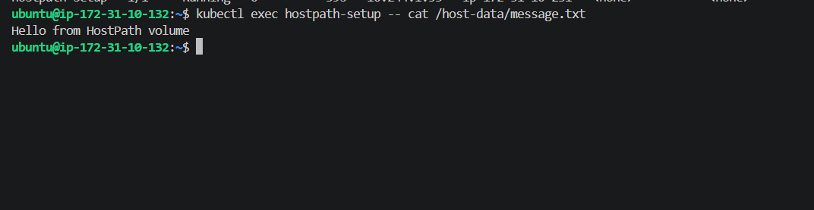
This proves:
Worker Node
/data/hostpath/message.txt
↑
hostPath
↓
Pod
/host-data/message.txt
Next: Test persistence
This is the important part. We'll delete the current Pod and create another Pod on the same worker node, mounting the same:
/data/hostpath
If the file is still there, it proves the data belongs to the node's filesystem, not the Pod.
First, delete the temporary setup Pod:
kubectl delete pod hostpath-setup
Expected:
pod "hostpath-setup" deleted
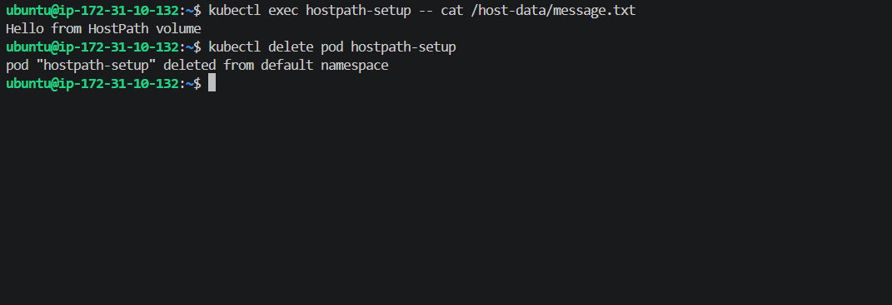
Step 4 — Create a verification Pod
Run:
vi hostpath-verify.yaml
Paste:
apiVersion: v1
kind: Pod
metadata:
name: hostpath-verify
spec:
nodeName: ip-172-31-10-231
containers:
- name: verify
image: busybox
command:
- sh
- -c
- |
cat /host-data/message.txt
sleep 3600
volumeMounts:
- name: host-storage
mountPath: /host-data
volumes:
- name: host-storage
hostPath:
path: /data/hostpath
type: Directory
Apply it:
kubectl apply -f hostpath-verify.yaml
Then:
kubectl get pod hostpath-verify -o wide
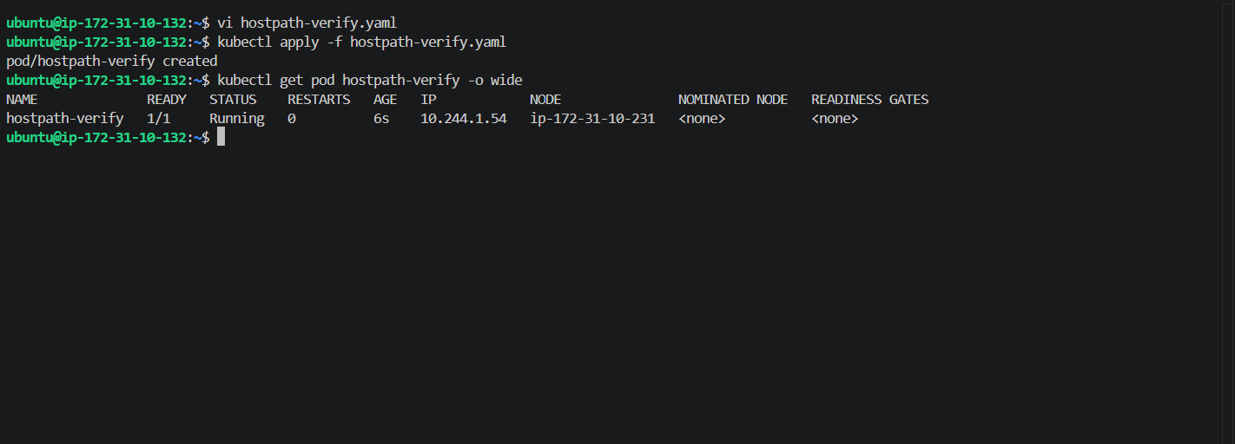

Now let's perform the actual persistence check.
Run:
kubectl exec hostpath-verify -- cat /host-data/message.txt
Expected output
Hello from HostPath volume
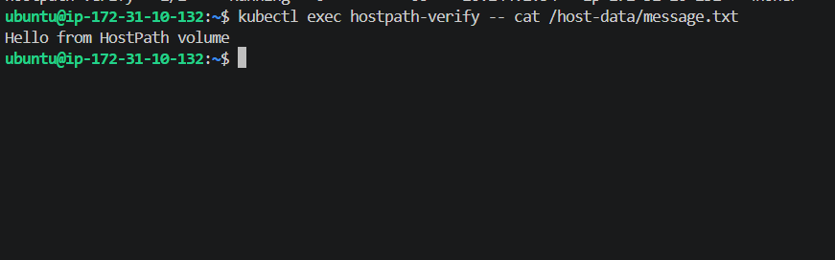
Task 2 (HostPath) is completely completed.
You deleted the first Pod:
hostpath-setup
Then created a new Pod:
hostpath-verify 1/1 Running
on the same worker:
ip-172-31-10-231
And the new Pod successfully read:
Hello from HostPath volume
🎯 What we proved
Pod 1
↓
writes message.txt
↓
Worker's /data/hostpath
↓
Pod 1 deleted ❌
↓
Pod 2 created
↓
reads message.txt ✅
So the data persisted after Pod deletion because it was stored on the worker node's filesystem.
Task 3: Amazon EBS + PersistentVolume (PV) + PersistentVolumeClaim (PVC).
Step 1 — Check your Kubernetes StorageClasses
Check whether the EBS CSI driver components exist
Run:
kubectl get pods -A | grep -i ebs
Restart the EBS CSI controller
Run:
kubectl rollout restart deployment ebs-csi-controller -n kube-system
You should see:
deployment.apps/ebs-csi-controller restarted
Check the EBS CSI controller
Run:
kubectl get pods -n kube-system | grep ebs-csi-controller
Send me the output.
We want both controller pods to eventually show:
6/6 Running
Create a 1 GiB EBS volume
We'll create it in the worker's AZ:
ap-south-1b
Run:
aws ec2 create-volume \
--availability-zone ap-south-1b \
--size 1 \
--volume-type gp3 \
--tag-specifications 'ResourceType=volume,Tags=[{Key=Name,Value=k8s-task8-ebs}]'
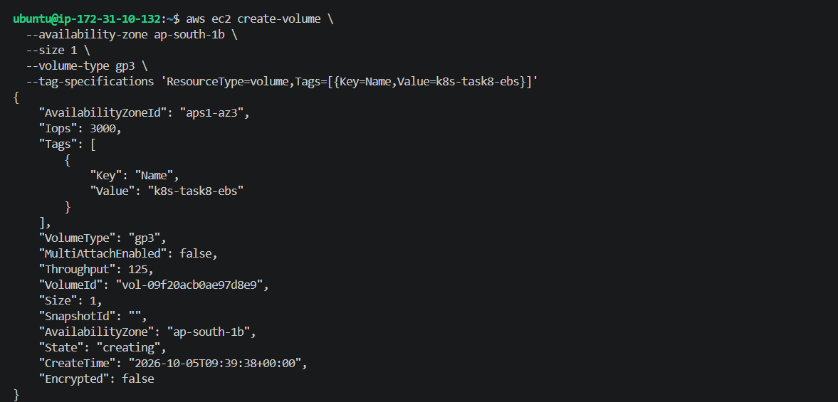
Step 27 — Check the EBS volume status
Run:
aws ec2 describe-volumes \
--volume-ids vol-09f20acb0ae97d8e9 \
--query 'Volumes[0].[VolumeId,State,AvailabilityZone,Size,VolumeType]' \
--output table
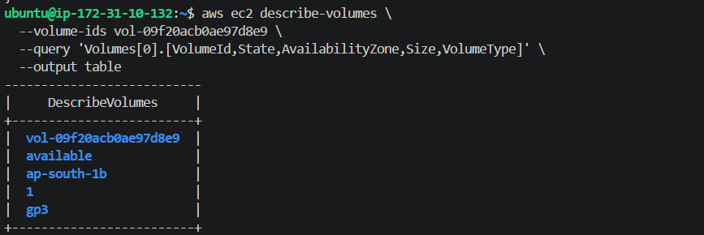
Create the PersistentVolume (PV)
We'll bind this PV to your 1 GiB EBS volume:
vol-09f20acb0ae97d8e9
Create the YAML:
nano ebs-pv.yaml
Paste this complete file:
apiVersion: v1
kind: PersistentVolume
metadata:
name: ebs-pv
spec:
capacity:
storage: 1Gi
volumeMode: Filesystem
accessModes:
- ReadWriteOnce
persistentVolumeReclaimPolicy: Delete
storageClassName: ebs-static
csi:
driver: ebs.csi.aws.com
volumeHandle: vol-09f20acb0ae97d8e9
fsType: ext4
nodeAffinity:
required:
nodeSelectorTerms:
- matchExpressions:
- key: kubernetes.io/hostname
operator: In
values:
- ip-172-31-10-231
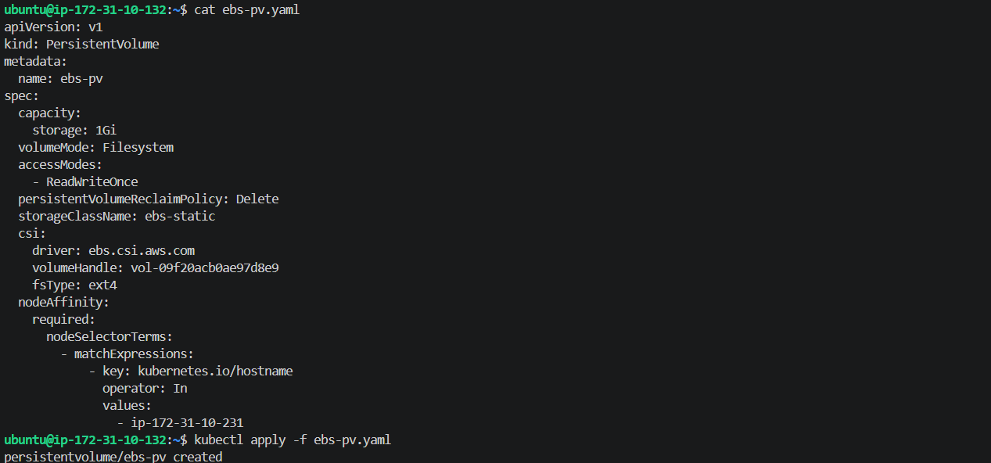
Check the PV
Run:
kubectl get pv ebs-pv
Send me the output.
We want to see something like:
NAME CAPACITY ACCESS MODES RECLAIM POLICY STATUS CLAIM STORAGECLASS
ebs-pv 1Gi RWO Delete Available ebs-static
Create the PersistentVolumeClaim (PVC)
Now we'll create a PVC that requests 1 GiB and matches the ebs-static storage class.
Create the file:
nano ebs-pvc.yaml
Paste:
apiVersion: v1
kind: PersistentVolumeClaim
metadata:
name: ebs-pvc
spec:
accessModes:
- ReadWriteOnce
storageClassName: ebs-static
resources:
requests:
storage: 1Gi
Then apply:
kubectl apply -f ebs-pvc.yaml
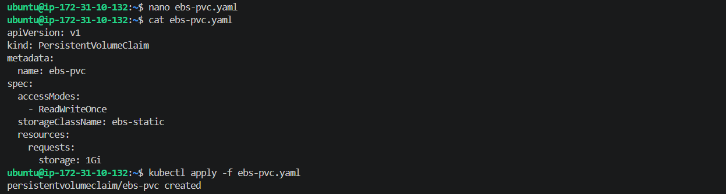
Check the PVC
Run:
kubectl get pvc ebs-pvc
We want the status to be:
Bound
Create a Pod that uses the EBS PVC
Now we need to actually mount the EBS volume inside a Pod and test that data can be written to it.
Create:
nano ebs-test-pod.yaml
Paste this complete YAML:
apiVersion: v1
kind: Pod
metadata:
name: ebs-test-pod
spec:
nodeName: ip-172-31-10-231
containers:
- name: ebs-test
image: busybox
command:
- sh
- -c
- |
echo "Hello from Amazon EBS Persistent Volume" > /data/message.txt
cat /data/message.txt
sleep 3600
volumeMounts:
- name: ebs-storage
mountPath: /data
volumes:
- name: ebs-storage
persistentVolumeClaim:
claimName: ebs-pvc
Save it, then apply:
kubectl apply -f ebs-test-pod.yaml
Check the Pod
Run:
kubectl get pod ebs-test-pod -o wide
Send me the output.
We want to see:
STATUS Running

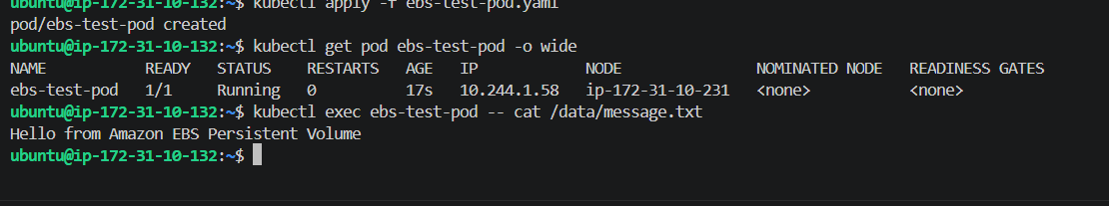
Task 8.4 — Amazon EFS + Multiple Pods
Step 1 — Check whether EFS CSI Driver already exists
Run:
kubectl get csidriver
We should now see:
ebs.csi.aws.com
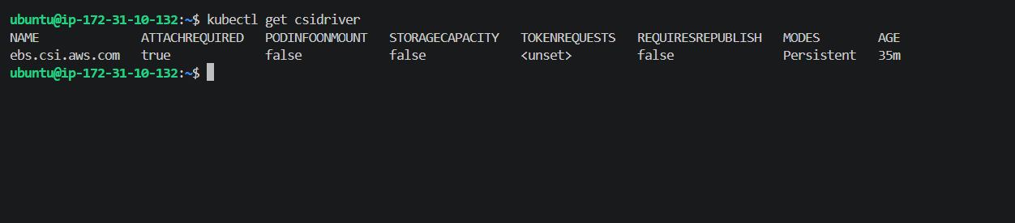
So EFS CSI Driver is not installed yet.
For EFS, we need three main things:
- EFS filesystem in AWS
- EFS CSI Driver in Kubernetes
- EFS mount targets + network access so Pods can mount the filesystem
We'll do them one at a time.
Step 2 — Find the VPC and subnet details of your second worker
Your EFS should ideally have access from the subnets where your Kubernetes workers run.
Run:
aws ec2 describe-instances \
--filters "Name=private-ip-address,Values=172.31.6.202" \
--query 'Reservations[].Instances[].[InstanceId,VpcId,SubnetId,Placement.AvailabilityZone]' \
--output table
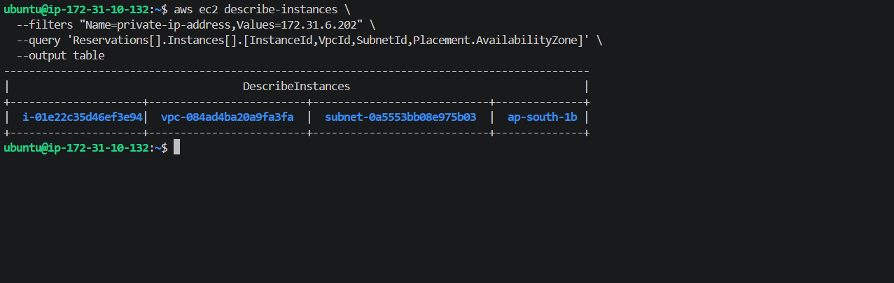
Step 3 — Check the subnet's route table
Before creating EFS, let's verify the subnet's networking.
Run:
aws ec2 describe-route-tables \
--filters "Name=association.subnet-id,Values=subnet-0a5553bb08e975b03" \
--query 'RouteTables[].Routes[].[DestinationCidrBlock,GatewayId,NatGatewayId]' \
--output table
Step 4 — Check the VPC's main route table
Run:
aws ec2 describe-route-tables \
--filters "Name=vpc-id,Values=vpc-084ad4ba20a9fa3fa" \
--query 'RouteTables[].[RouteTableId,Associations[0].Main,Routes[].[DestinationCidrBlock,GatewayId,NatGatewayId]]' \
--output table
Step 5 — Check the subnet's CIDR
For the EFS mount target, we'll need the subnet CIDR.
Run:
aws ec2 describe-subnets \
--subnet-ids subnet-0a5553bb08e975b03 \
--query 'Subnets[0].[SubnetId,VpcId,CidrBlock,AvailabilityZone]' \
--output table
Step 6 — Check the existing security groups in this VPC
Run:
aws ec2 describe-security-groups \
--filters "Name=vpc-id,Values=vpc-084ad4ba20a9fa3fa" \
--query 'SecurityGroups[].[GroupId,GroupName,Description]' \
--output table
Step 7 — Create an EFS security group
Run:
aws ec2 create-security-group \
--group-name k8s-efs-sg \
--description "Security group for Kubernetes EFS" \
--vpc-id vpc-084ad4ba20a9fa3fa
Step 8 — Add NFS inbound rule
Run:
aws ec2 authorize-security-group-ingress \
--group-id sg-014856cd5eaf2d089 \
--protocol tcp \
--port 2049 \
--cidr 172.31.0.0/20
Step 9 — Create the EFS filesystem
Now we'll create the actual EFS filesystem.
Run:
aws efs create-file-system \
--region ap-south-1 \
--performance-mode generalPurpose \
--throughput-mode bursting \
--encrypted \
--tags Key=Name,Value=k8s-task8-efs
Step 10 — Check whether the EFS filesystem is ready
Run:
aws efs describe-file-systems \
--file-system-id fs-09284d62472e86893 \
--query 'FileSystems[0].[FileSystemId,LifeCycleState,NumberOfMountTargets]' \
--output table
Step 11 — Create the EFS mount target
Run:
aws efs create-mount-target \
--file-system-id fs-09284d62472e86893 \
--subnet-id subnet-0a5553bb08e975b03 \
--security-groups sg-014856cd5eaf2d089
Step 12 — Wait for the mount target to become available
Run:
aws efs describe-mount-targets \
--file-system-id fs-09284d62472e86893 \
--query 'MountTargets[0].[MountTargetId,LifeCycleState,IpAddress,AvailabilityZoneName]' \
--output table
Next: Install the EFS CSI Driver
Before creating the PV/PVC, Kubernetes needs the Amazon EFS CSI driver.
Run this command:
kubectl apply -k "https://github.com/kubernetes-sigs/aws-efs-csi-driver/deploy/kubernetes/overlays/stable/?ref=release-2.2"
Step 13 — Verify the EFS CSI Driver
Run:
kubectl get pods -n kube-system -l app.kubernetes.io/name=aws-efs-csi-driver
Step 14 — Create EFS PV
Run:
cat > efs-pv.yaml <<'EOF'
apiVersion: v1
kind: PersistentVolume
metadata:
name: efs-pv
spec:
capacity:
storage: 1Gi
volumeMode: Filesystem
accessModes:
- ReadWriteMany
persistentVolumeReclaimPolicy: Retain
storageClassName: efs-static
mountOptions:
- tls
csi:
driver: efs.csi.aws.com
volumeHandle: fs-09284d62472e86893
EOF
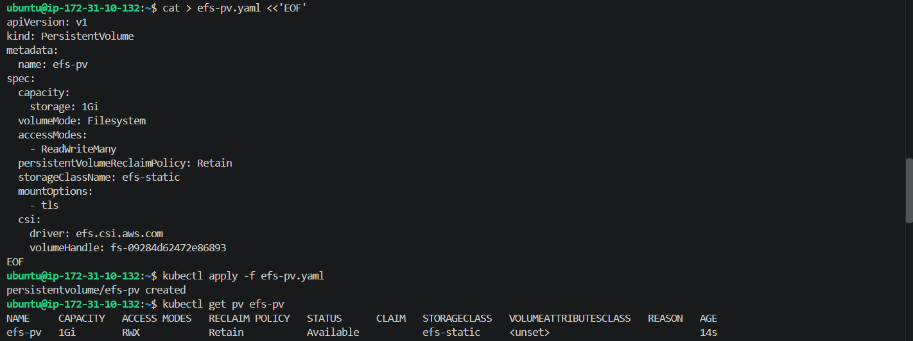
Step 15 — Create the EFS PVC
Run:
cat > efs-pvc.yaml <<'EOF'
apiVersion: v1
kind: PersistentVolumeClaim
metadata:
name: efs-pvc
spec:
accessModes:
- ReadWriteMany
storageClassName: efs-static
resources:
requests:
storage: 1Gi
EOF
Then apply it:
kubectl apply -f efs-pvc.yaml
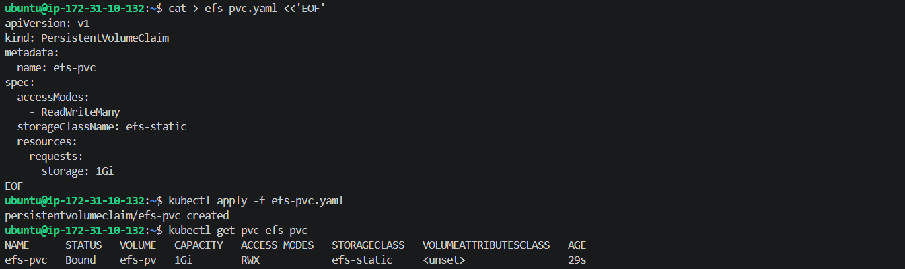
Create the first Pod
This Pod will write a file to EFS.
Run:
cat > efs-writer-pod.yaml <<'EOF'
apiVersion: v1
kind: Pod
metadata:
name: efs-writer-pod
spec:
nodeName: ip-172-31-10-231
containers:
- name: writer
image: busybox
command:
- sh
- -c
- |
echo "Hello from EFS shared storage" > /data/message.txt
cat /data/message.txt
sleep 3600
volumeMounts:
- name: efs-storage
mountPath: /data
volumes:
- name: efs-storage
persistentVolumeClaim:
claimName: efs-pvc
EOF
Then apply it:
kubectl apply -f efs-writer-pod.yaml
Then check the Pod:
kubectl get pod efs-writer-pod -o wide
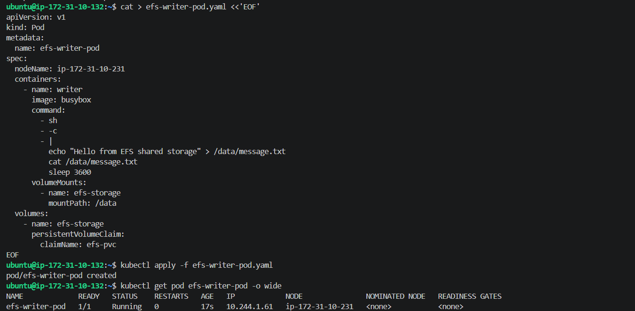
Step 17 — Verify the file
Run:
kubectl exec efs-writer-pod -- cat /data/message.txt
Expected:
Hello from EFS shared storage
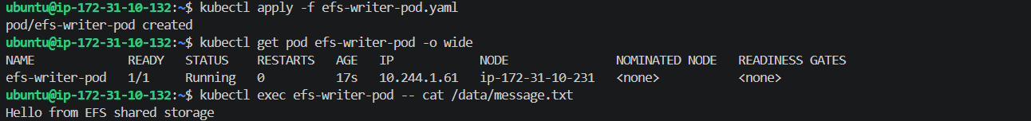
Step 18 — Create the second Pod
This Pod will run on Worker 2 and read the file created by Worker 1's Pod.
Run:
cat > efs-reader-pod.yaml <<'EOF'
apiVersion: v1
kind: Pod
metadata:
name: efs-reader-pod
spec:
nodeName: ip-172-31-6-202
containers:
- name: reader
image: busybox
command:
- sh
- -c
- |
sleep 5
cat /data/message.txt
sleep 3600
volumeMounts:
- name: efs-storage
mountPath: /data
volumes:
- name: efs-storage
persistentVolumeClaim:
claimName: efs-pvc
EOF
Then apply it:
kubectl apply -f efs-reader-pod.yaml
Then check both Pods:
kubectl get pods -o wide | grep efs
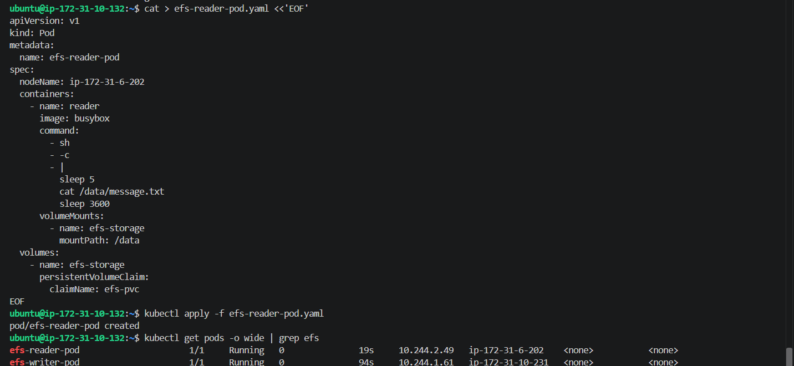
Step 19 — Verify shared EFS data
Now run:
kubectl exec efs-reader-pod -- cat /data/message.txt
Step 1 — Create the Pod YAML
Run:
cat > probes-pod.yaml <<'EOF'
apiVersion: v1
kind: Pod
metadata:
name: probes-pod
labels:
app: probes-demo
spec:
containers:
- name: nginx
image: nginx:latest
ports:
- containerPort: 80

livenessProbe:
httpGet:
path: /
port: 80
initialDelaySeconds: 10
periodSeconds: 5

readinessProbe:
httpGet:
path: /
port: 80
initialDelaySeconds: 5
periodSeconds: 5
EOF
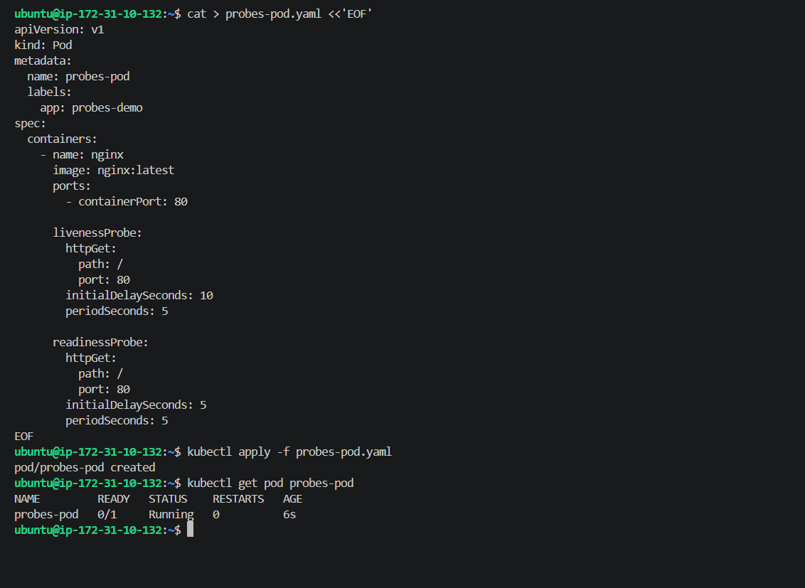
Step 3 — Verify both probes
Wait about 15 seconds, then run:
kubectl get pod probes-pod
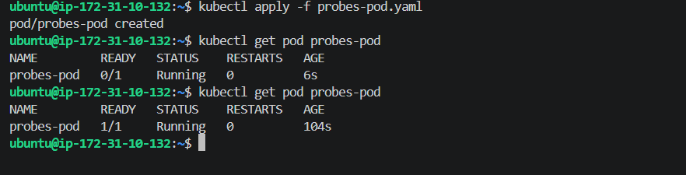
Step 4 — Check the probe events
Run:
kubectl describe pod probes-pod
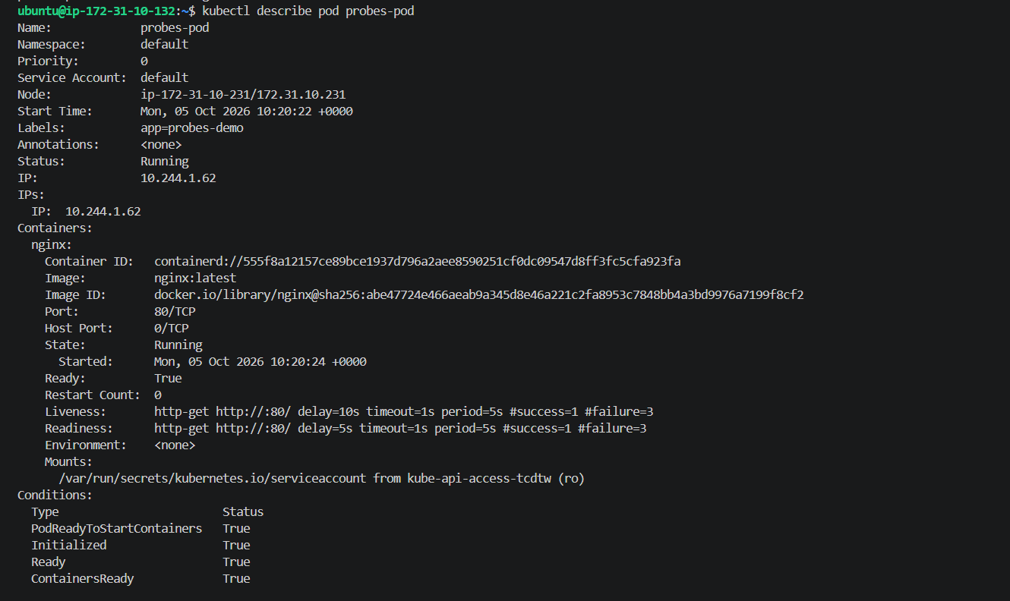
Step 5 — Test Readiness Probe
We'll temporarily make NGINX return a failure for the readiness check. The easiest safe way is to change the probe's path to a nonexistent page.
First, create a modified test YAML:
cat > probes-readiness-fail.yaml <<'EOF'
apiVersion: v1
kind: Pod
metadata:
name: probes-readiness-test
labels:
app: probes-readiness-test
spec:
containers:
- name: nginx
image: nginx:latest
ports:
- containerPort: 80

readinessProbe:
httpGet:
path: /does-not-exist
port: 80
initialDelaySeconds: 5
periodSeconds: 5
EOF
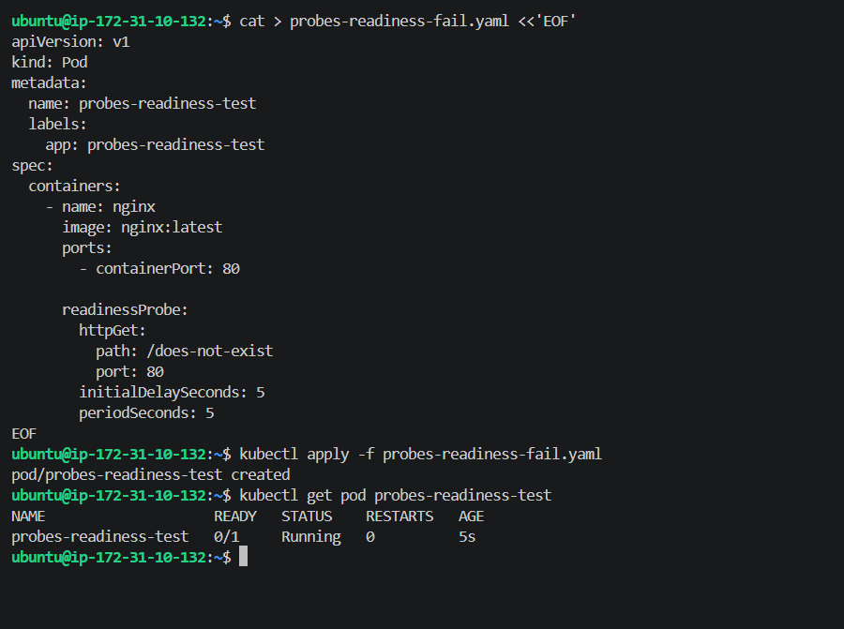
Step 6 — Confirm the readiness failure
Wait about 10 seconds, then run:
kubectl describe pod probes-readiness-test
At the bottom, under Events, we should see something similar to:
Readiness probe failed: HTTP probe failed with statuscode: 404
Also, the Pod should remain:
0/1 Running
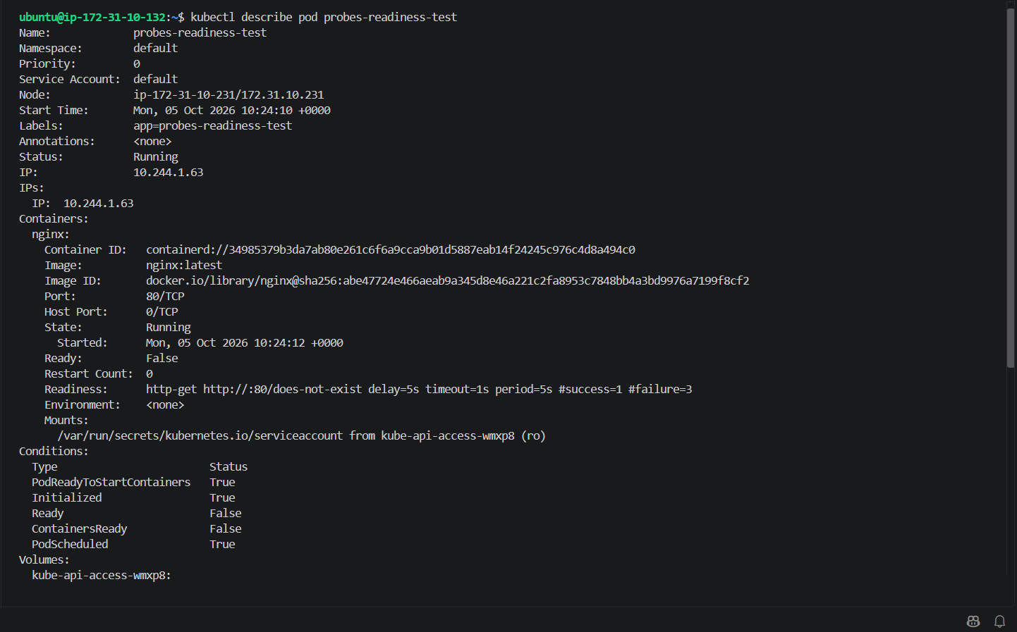
Step 7 — Test the Liveness Probe
Now we'll create a separate Pod where the liveness probe intentionally fails.
Run:
cat > probes-liveness-fail.yaml <<'EOF'
apiVersion: v1
kind: Pod
metadata:
name: probes-liveness-test
spec:
containers:
- name: nginx
image: nginx:latest
ports:
- containerPort: 80

livenessProbe:
httpGet:
path: /does-not-exist
port: 80
initialDelaySeconds: 5
periodSeconds: 5
failureThreshold: 2
EOF
Then apply it:
kubectl apply -f probes-liveness-fail.yaml
Now wait about 15–20 seconds so Kubernetes can perform the failed liveness checks, then run:
kubectl get pod probes-liveness-test
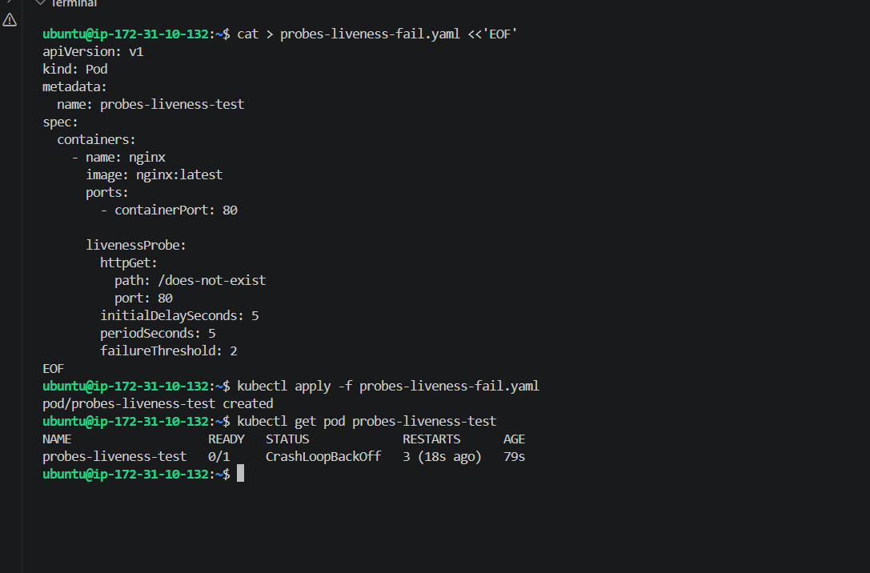
Step 8 — Confirm the liveness failure event
Run:
kubectl describe pod probes-liveness-test
Look at the Events section. We should see messages such as:
Liveness probe failed: HTTP probe failed with statuscode: 404
